Seminarios DQIAQF - INQUIMAE, lunes 13 de junio - 13 hs.
Aula de Seminarios INQUIMAE - DQIAQF
Facultad de Ciencias Exactas y Naturales
Ciudad Universitaria - Pab. 2 - Piso 3

Prof. Dr. Axel Klein
University of Cologne
Department of Chemistry
Institute for Inorganic Chemistry
Greinstrasse 6 – 50939 Koeln
Germany

Spectroelectrochemistry for the investigation of redox-catalytic processes

Spectroelectrochemistry (in situ electrochemistry + spectroscopy) is a powerful method to investigate redox-processes in catalytic processes. The lecture will briefly introduce into the method and then present a number of examples of spectroelectrochemical investigations on transition metal complexes with relevance in catalysis.
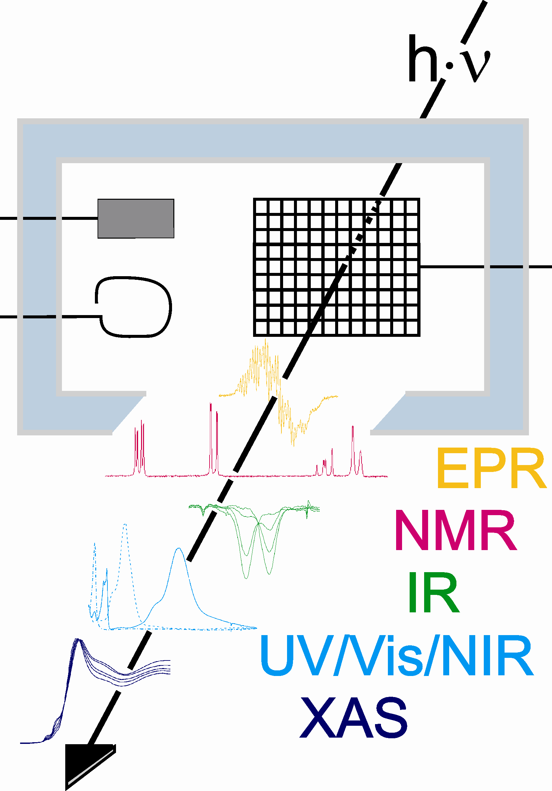

Dr. Axel Klein is a full professor at the University of Cologne (Germany) since 2004.
He has studied Chemistry at the University of Stuttgart. In 2002 he was a visiting professor in Tübingen (Germany) and 2003 and 2004 in Graz (Austria).

