
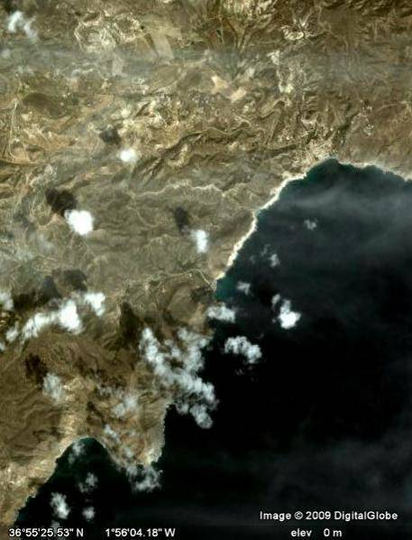
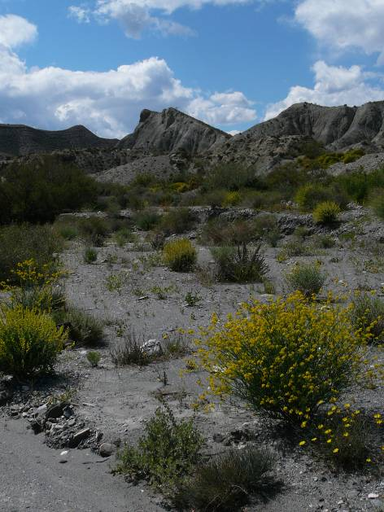

Postdoctoral fellow in Mathematical Ecology: spatial scaling of biodiversity

We are looking for a postdoctoral research fellow to develop and apply spatial ecological theory. The work would explore spatial aspects of population dynamics, species diversity and conservation biology, focussing on the development of a modelling framework that combines processes across different spatial scales. The work would involve a mixture of theory development and analysis, to address (for example) the effects of population interactions at different spatial scales, the spatial scaling of beta-diversity, effects of autocorrelated disturbance on species diversity, and methods for up-scaling and down-scaling ecological information. Fluency in computer programming and mathematical techniques for spatial modelling would be essential for this post; good communication and leadership skills would be extremely useful. The post is part of the EU-FP7 SCALES (“Securing Conservation of biodiversity across Administrative Levels and spatial and temporal Ecological Scales”) project, and so would involve collaborations with an interdisciplinary team of scientists from across Europe (and beyond).

Initial appointment would be for a period of 48 months.

University Grade 7 (£28,290 - £33,780)

Informal enquiries to:
Dr. William Kunin, w.e.kunin@leeds.ac.uk tel: +44 (0)113 343 2857; or
Dr. Stephen Cornell, s.j.cornell@leeds.ac.uk tel: +44 (0)113 343 2899

To apply on line please visit http://www.leeds.ac.uk and click on jobs.
Alternatively, application packs are available from: Mr A Bateman, Faculty Staff Recruitment Office, tel: +44 (0)113 343 8040, email fbsjobs@leeds.ac.uk

Job ref: 316162 Closing date: 18 May 2009

